Sponsoring the British Guild of Travel Writers (BGTW) is an excellent opportunity for DMOs, tourist boards, service providers and PR companies to increase brand awareness of their destination, client or product.

About Us
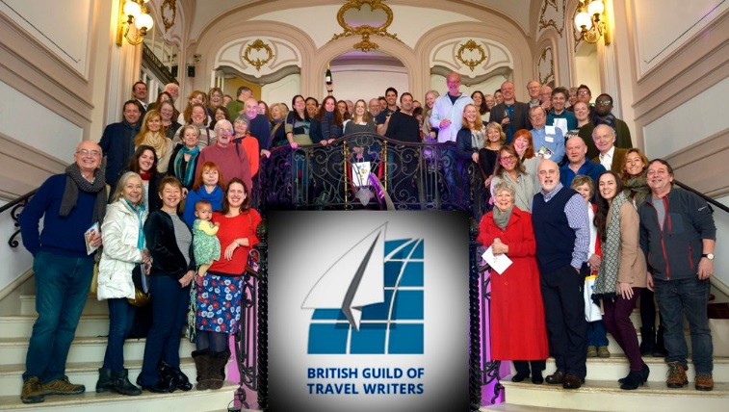

The BGTW has around 220 members, involved in everything from print to blogging, photography, broadcasting, vlogging and social media. The BGTW is:

A seal of quality
The Guild is the bastion of reliability in the fiercely competitive world of journalism. Membership criteria are rigorous and members adhere to a strict Code of Conduct.

Well-connected
The industry is all about extensive networking, and we particularly value our strong links with tourist boards, PR companies, hotel owners and tour operators.

Independent
We always get to the heart of a destination and find the real story. We are not easily influenced – by fads and fashions, or by any number of fancy cocktails or meals.

Experienced
Active since 1960, we have seen many changes to the media industry. Our members have not only been responding to these changes but influencing them.

Contemporary
We are at the forefront of industry trends; we visit emerging destinations; we write for online media, we vlog, and we have over 250,000 followers on social media.

Our Publications and Social Media
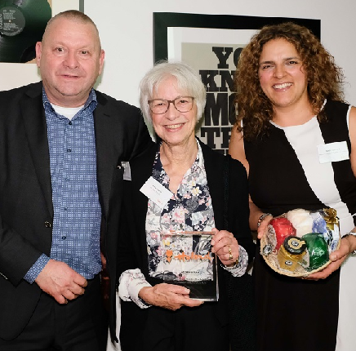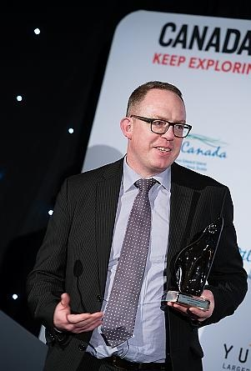

Recently our members have written - and won awards - for well-established, global, online and print publications in the consumer and trade sector, such as:

Magazines: National Geographic Traveller, Condé Nast, Wanderlust, in-flight magazines
Newspapers: The Times, The Telegraph, The Guardian, The Independent
Guide books: Lonely Planet, Rough Guides, Bradt, Frommer’s
Websites and blogs: Suitcase magazine, Adventure.com, Silver Travel Advisor
Trade publications: Travel Weekly, TTG, Travel Bulletin

Endorsements
TBC

Sponsorship Packages and Facilities
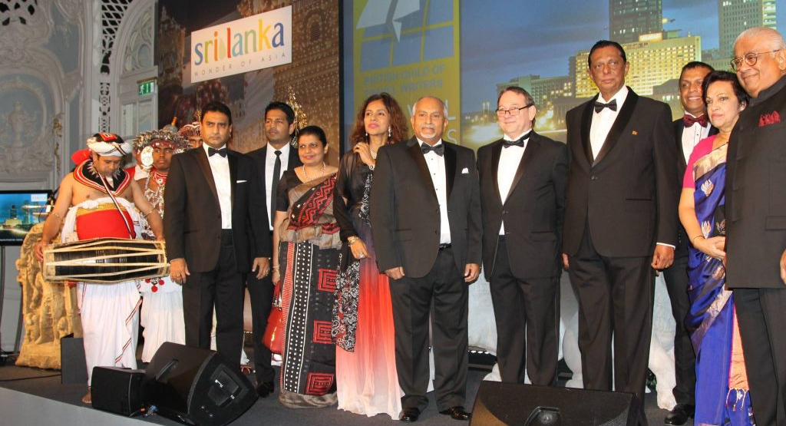

A number of products are available for sponsorship:

Gala Dinner
An event at The Savoy Hotel on the eve of World Travel Market, attended by 320 of the best names in the media and industry.

Yearbook
An annual directory of all Guild members, published and mailed to the UK’s commissioning editors and PRs.

Annual General Meeting
The Guild’s own AGM, attended by 100 members and including press trips around the region after a day of discussion.

Small Events
Educational and collaborative events featuring tips on professional development or social gatherings based across the UK

Facilities
Providers of goods and services to the travel industry offer special deals and discounts to our members, ranging from accommodation to clothing, airport parking to ferry crossings.

Contact
Are you interested in sponsoring one of our events or products or offering a facility?
Please email secretariat@bgtw.org or call 020 8144 8713 to discuss.

